**SOFTWARE REQUIREMENTS SPECIFICATIONS (SRS)**

* **PROJECT : WEB BASED CHAT APPLICATION**
* **Submitted By - Prince Kumar (17SCSE101358)**

**Yogesh Pandey (17SCSE1010003)**

**Batch - 11**

**ABSTRACT**

Teleconferencing or Chatting is basically a method of using technology to bring people and ideas together despite geographical barriers. This technology has been available for years but the acceptance of it was quite recent. This is an abstract defining the title/topic of the project assigned to our group in the Web Technology Project Based Learning (PBL) Programme. The topic that was allotted to us was “Designing a Web Chat Application”. A web chat application is a platform where a user or group of users get connected to a server which in turn enables them to share or communicate with each other via text messages.

**PROJECT INTRODUCTION**

* **Overall Description :**

**●**  There are numerous products available that facilitate real time communication over the internet via real time exchange of messages between one or more persons.

● The sole purpose of this project is to implement a web based messaging application that would allow users with an active internet connection to engage in private and public conversations.

● The development of this project centered on the development of a message protocol that would allow the application to properly log in users, send messages, and perform system maintenance (in case of admin).

* **Purpose :** Well before taking up this project and deciding to keep going with it, the first thing that we felt the need for was the purpose behind bringing this project to life. As far as the usage and convenience related to this project is considered, there are mainly two purposes that this project will be going to serve. These are :

● **Communication :** To develop an instant messaging solution to enable the users to seamlessly communicate with each other.

● **User-friendliness :** The project should be very easy to use in order to allow even a novice person to use it.

* **MOTIVATION AND SCOPE :** The Web Enabled Messaging system will be developed while keeping the following points of scope in mind :

● Broadcasting chat server application is going to be a text communication software. It will be able to communicate between two computers using point to point communication.

● The limitations of live chat is that it does not support audio communications. To overcome this limitation , we are currently working on developing better technologies.

● Companies would like to have a communication software wherein they can communicate instantly within their organization.

● The fact that the software uses an internal network setup within the organization makes it very secure from outside attacks.

* **PROJECT PERSPECTIVE :**

❖ The system to be developed here is a chat facility. It is a centralized system. It is a Client-Server system with a centralized database server. All local clients are connected to the centralized server via LAN.

❖ There is a two way communication between different clients and servers. This chat application can be used for group discussions. It allows users to find other logged in users.

* **INTERFACE :**

❖ This application interacts with the user thorugh GUI. The interface hence developed is simple , easy handle and self-explanatory.

❖ Once opened, the user will easily come into the flow with the application and easily uses all interfaces properly.

❖ However the basic interface available in our application is :

● Title Panel

● Content Panel

● Admin Panel

* **HARDWARE INTERFACE :** The minimum system requirements that would be just sufficient for our application to work are mentioned as follows :

● 128 MB RAM required

● Processor with speed of 500MHz

● Internet or LAN Connection

● MOUSE : 2 or 3 button mouse

● KEYBOARD : 101 key Keyboard

* **CONSTRAINTS : ●** The application does not by any means open the web browser. If a user wishes to open the web browser, he must open it externally.

● The system needs to be permanently connected to the internet**.**

* **PRODUCT FUNCTIONS :**

❖ There is a two way communication between different clients and the server.

❖ This chat application can be used for group discussions.

❖ It allows the users to find other logged in users.

* **ASSUMPTIONS AND DEPENDENCIES :**

❖ There should be a LAN or Internet Connection.

❖ Clients should know each other.

❖ There can be multiple clients.

* **USE CASE DIAGRAM :**

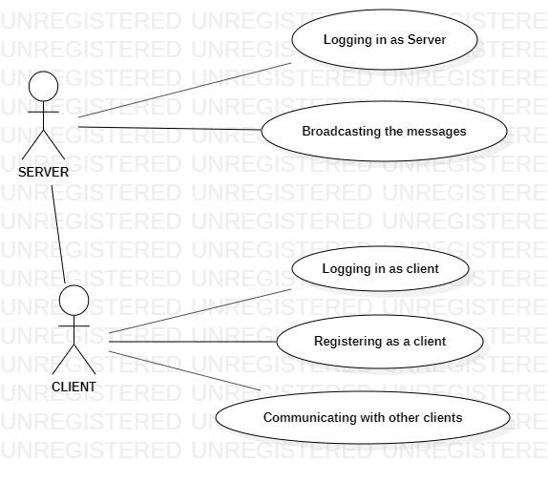

* **ACTIVITY DIAGRAMS/ FLOWCHART :**

1. **For Logging In :**

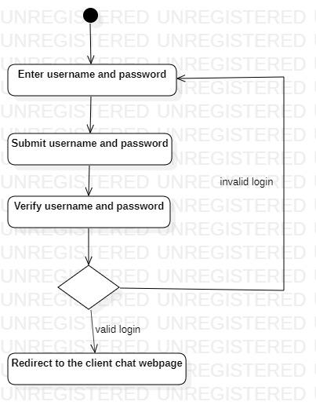

1. **For Messaging (utilizing the system resources) :**

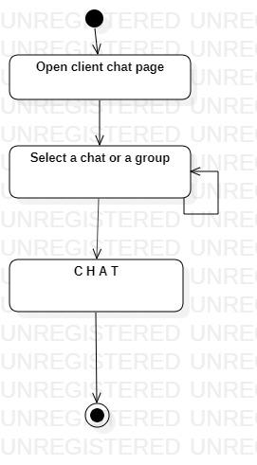

* **REFERENCES :**

➢ : The links of all the resources and articles that we made use of, while developing this project are all mentioned below with sufficient clarification :

1. **HTML and CSS Formatting Techniques :**

* <https://www.w3schools.com/htmL/html_css.asp>
* <https://www.w3schools.com/css/css_text.asp>
* <https://www.w3schools.com/tags/ref_byfunc.asp>
* <https://html.com/tags/>
* <https://www.youtube.com/watch?v=nJjbbAC2N28&list=PLdYkObur3tQtBTbYirZGcrWPuPRmmDA6n>

1. **PHP SCRIPTING TUTORIALS :**

* <https://www.w3schools.com/PHP/DEfaULT.asP>
* <https://www.youtube.com/watch?v=13F0hgvOip8&list=PLdYkObur3tQvwIBNvfSYY2xHIFyT9hHtz>
* <https://www.thoughtco.com/php-with-html-2693952>

1. **CREATING DATABASES AND SERVERS :**

* <https://www.javatpoint.com/dbms-tutorial>
* <https://www.youtube.com/watch?v=WKWZZcrin5I>
* <https://www.wikihow.com/Create-a-Database-in-phpMyAdmin>

1. **TUTORIALS ABOUT WAMP AND XAMPP SERVERS :**

* <https://stackoverflow.com/questions/24639237/wamp-and-xampp-on-same-machine>
* <https://www.youtube.com/watch?v=LM7LK7HnRBo>

1. **ESTABLISHING CONNECTION WITH THE DATABASE :**

* <https://www.w3schools.com/php/php_mysql_connect.asp>
* <https://www.youtube.com/watch?v=DZrUq8BmTwY>

1. **USING LOCALHOST :**

* <https://www.youtube.com/watch?v=k9em7Ey00xQ>
* <https://helpdeskgeek.com/networking/what-is-localhost-and-how-can-you-use-it/>